COOPLAG Commissions Q2 Luxury Apartments, Advancing Its Commitment to Quality Housing
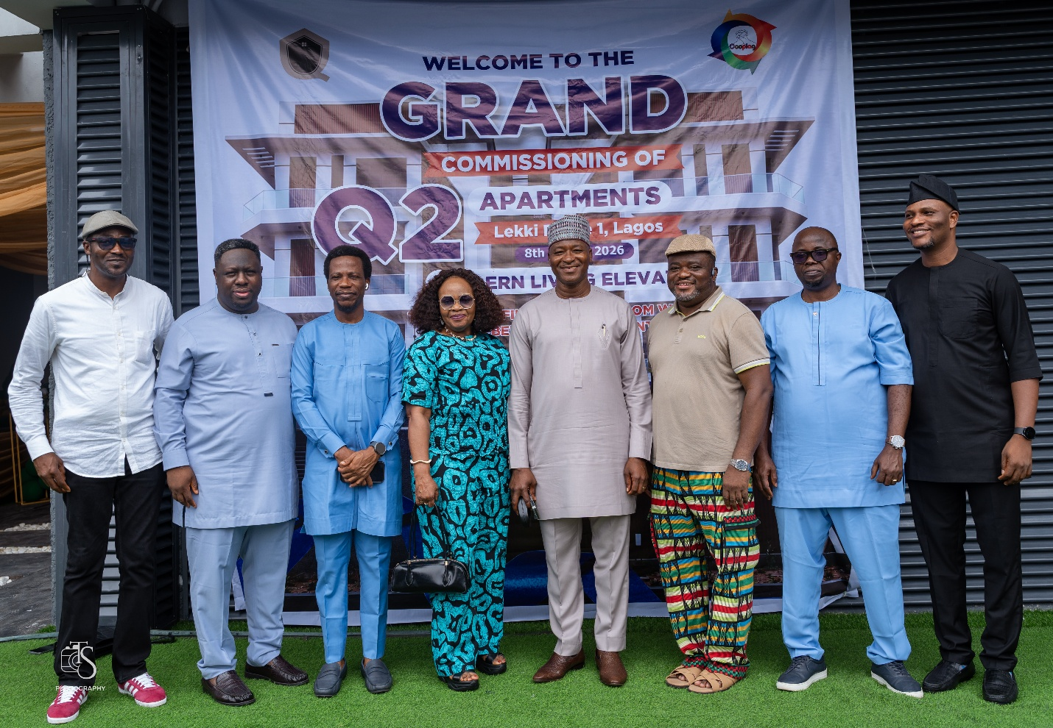

A landmark delivery strengthens COOPLAG's vision of creating quality homes, building member wealth and contributing to Nigeria's housing future
COOPLAG Cooperative Investment & Thrift Society Limited has officially commissioned Q2 Apartments in Lekki Phase 1, Lagos, marking another significant milestone in its growing real estate portfolio and its commitment to deliver quality housing solutions that create lasting value.
The development comprises 14 units of two bedroom with BQ and three-bedroom apartments, providing modern residential accommodation in one of Lagos' highly sought-after locations.
The successful completion of Q2 comes against the backdrop of a challenging housing environment in Nigeria, where rising construction costs, inflation, limited access to mortgage finance and reduced purchasing power continue to impact housing delivery. Against these realities, the project demonstrates the value of sustained cooperative and private-sector participation in creating quality housing opportunities.
Building Homes. Creating Lasting Value.
Speaking at the commissioning, COOPLAG President, Aremo Francis Adeoye, reaffirmed the Society's commitment to contributing to the housing needs of its members and the wider society.
His remarks underscored COOPLAG's approach to real estate development: delivering quality homes, creating value and pursuing affordability, while using its investment initiatives to enhance the welfare and financial position of its members.
The delivery of Q2 reflects this philosophy in action, transforming cooperative participation and investment into tangible assets and quality residential communities.
Designed with Members in Mind
COOPLAG Vice President, Levious Ngerebara, highlighted the member-focused approach behind the development, noting that Q2 was designed with salaried workers and COOPLAG members in mind.
This approach reflects an important part of COOPLAG's real estate strategy: developing housing solutions that respond to the realities and purchasing power of the people they are intended to serve.
The discussion also reinforced the importance of accessible financing in expanding housing opportunities, particularly through stronger collaboration between government-backed financing initiatives, cooperative societies and private-sector developers.
More Than a Property
For COOPLAG, every completed development represents more than bricks, concrete and architecture.
It represents an opportunity to help members own assets, build wealth, secure their future and improve their quality of life.
Q2 Apartments embodies this vision by bringing together quality residential development, strategic location and member-focused investment, demonstrating how cooperative resources can be channeled into projects with tangible and lasting value.
From Vision to Delivery
The commissioning of Q2 is another demonstration of COOPLAG's commitment to turning development plans into completed projects.
From conception through construction to completion, the project reflects the Society's focus on quality, integrity, delivery and sustainable value creation.
As COOPLAG continues to expand its real estate portfolio, Q2 joins a growing collection of developments that demonstrate what is possible when cooperative investment, professional expertise and commitment to delivery come together.
Another Milestone. Another Promise Delivered.
Q2 Luxury Apartments is not simply another complete development. It is another step in COOPLAG's broader vision of building homes, creating assets, enhancing member welfare and contributing to the future of housing in Nigeria.
As the Society looks ahead, COOPLAG remains committed to pursuing strategic real estate opportunities that deliver meaningful value to its members while contributing to the development of thriving communities.
COOPLAG: Building Wealth. Creating Opportunities. Delivering Value.

